9.47: Expressing in terms of 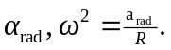 Combining with 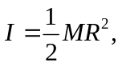 Eq. (9.17) becomes 